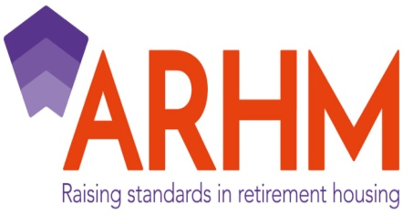

**Association of Retirement Housing Managers – Code of Practice, one year on.**

The ARHM celebrated the long awaited launch of its Government approved Code of Practice on 1st June 2016, alongside our 25th Anniversary. The ARHM represents around 50 member organisations who manage circa 90,000 retirement properties in the UK. It is also the only body that jointly represents both the private sector and registered social landlords and is widely consulted on various matters by both the Government and other professional bodies.

The ARHM is committed to continually raise standards within the sector by promoting best practice amongst those managing retirement housing. We have recently undertaken audit compliance checks across our whole membership to ensure members comply with the Code of Practice which is a condition of membership. We hope this provides reassurance to leaseholders that they are being managed by an organisation that commits to manage at the highest level. It is also committed to promoting quality and professionalism through training and education of its members and perhaps most importantly, championing the benefits of retirement housing.

We work closely with the EAC and were delighted to be given the opportunity to showcase 3 awards at the EAC Awards in Birmingham on 16th May. These awards symbolise the professionalism of our members and their commitment to making sure that leaseholders buying into the retirement sector have good quality information and are able to make an informed choice. This is increasingly important with the inevitable growth in the sector in the future to meet the challenges of a growing older population.

Our audit process assesses compliance across the Code of Practice in its entirety and we looked at the evidence provided by members in 2 key areas for the awards; the Leaseholder Handbook and Pre Sales Information. The Code of Practice provides clear guidance regarding the content of the Leaseholder Handbook and we looked at how our members had created their publications and added to them to create a detailed introduction to what it means to be a leaseholder and what, in turn, they may expect from their landlord or managing agent; this is particularly important as many people who purchase leasehold retirement properties have not come across the tenure before.

With the recent publication of the Law Commission Report on Event Fees at the end of March, it is clear that there is an expectation on managers to ensure that prospective purchasers are made aware, not only of the initial premium payable to purchase the property, but also all ongoing financial obligations they will be required to make whilst in occupation and when they leave. Our award for really comprehensive and good quality pre sales information recognises this.

PRE SALES INFORMATION

Awarded to Goldsborough Estates

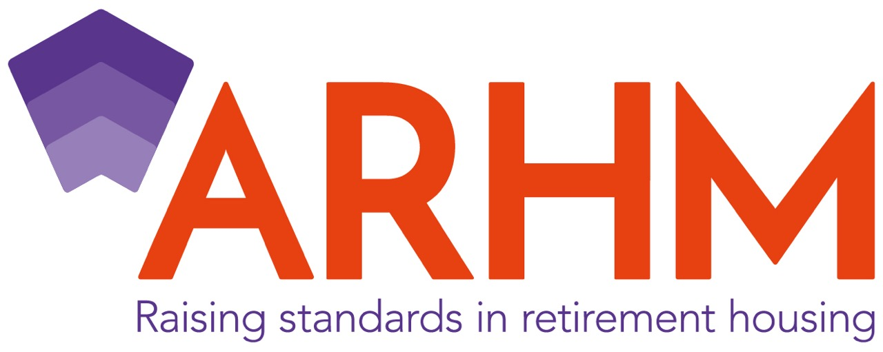

LEASEHOLDER HANDBOOK

Awarded to the ELM Group



GOING THE EXTRA MILE IN MANAGEMENT

Awarded to Housing & Care 21



Our award for going the extra mile in management reflects an organisation that has consistently demonstrated going over and above what is required in terms of the quality of information provided to its leaseholders and created real opportunities for engagement with its leaseholders to ensure that there is a clear understanding of the service offered.

For more information about the ARHM please visit our website arhm.org or telephone us on 0207 463 0660

ENDS