SPECIAL EVENTS
In June Davlyn House had some very special events, Father Day a special day for many people was celebrated by one of our residents Dennis Wheatcroft with a presentation of a Platinum Jubilee Medal.
Dennis served for over 50 years in the Territorial Army and rose to the rank of Colonel, to celebrate the Queens Platinum Jubilee he was awarded this very special medal. A true gentleman treats everyone with dignity and respect.
The Village Church included a celebration of Dennis achievement in their Father’s Day Service. Ruth our Minister delivered a beautiful tribute to Dennis and talked about his service and dedication to the Queen and his country. It was a special day and Dennis was supported by his children their partners and his grandchildren. Dennis and his family were warmly welcomed by all the congregation.

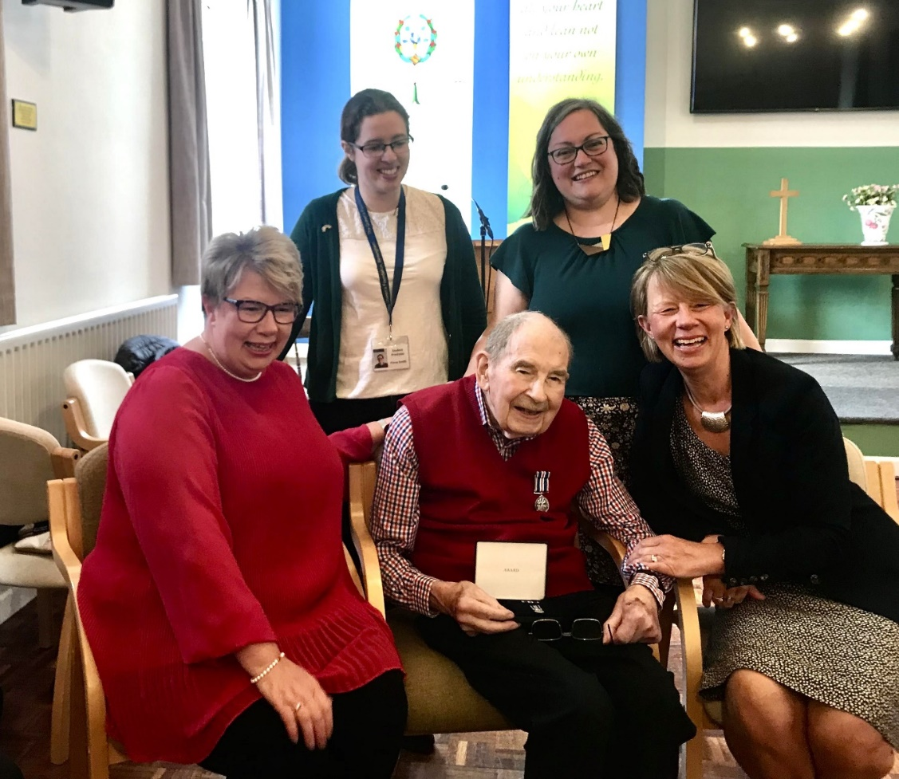

Our Platinum Jubilee events also included a garden party held in glorious weather; residents and their relatives enjoyed a visit by Elvis who entertained our residents making each one of them feel special. Elvis (Jason Dale) very kindly gave his time freely and was accompanied by his partner Debbie and mum Suzanne. Wonderful food was served by staff, friends and for the first time in along time by visiting children.
Highlights included a duet sung by our very own Roy and Elvis, a happy birthday message to 99-year-old Nellie and of course tributes to the Queen.

